Visible and Ultraviolet Spectroscopy

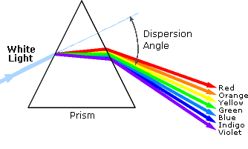
1. Background
An obvious difference between certain compounds is their color. Thus, quinone is yellow; chlorophyll is green; the 2,4-dinitrophenylhydrazone derivatives of aldehydes and ketones range in color from bright yellow to deep red, depending on double bond conjugation; and aspirin is colorless. In this respect the human eye is functioning as a spectrometer analyzing the light reflected from the surface of a solid or passing through a liquid. Although we see sunlight (or white light) as uniform or homogeneous in color, it is actually composed of a broad range of radiation wavelengths in the ultraviolet (UV), visible and infrared (IR) portions of the spectrum. As shown on the right, the component colors of the visible portion can be separated by passing sunlight through a prism, which acts to bend the light in differing degrees according to wavelength. Electromagnetic radiation such as visible light is commonly treated as a wave phenomenon, characterized by a wavelength or frequency. Wavelength is defined on the left below, as the distance between adjacent peaks (or troughs), and may be designated in meters, centimeters or nanometers (10⁻⁹ meters). Frequency is the number of wave cycles that travel past a fixed point per unit of time, and is usually given in cycles per second, or hertz (Hz). Visible wavelengths cover a range from approximately 400 to 800 nm. The longest visible wavelength is red and the shortest is violet. Other common colors of the spectrum, in order of decreasing wavelength, may be remembered by the mnemonic: ROY G BIV. The wavelengths of what we perceive as particular colors in the visible portion of the spectrum are displayed and listed below. In horizontal diagrams, such as the one on the bottom left, wavelength will increase on moving from left to right.
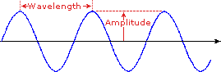
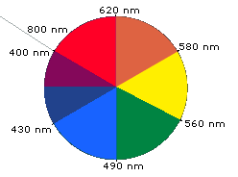
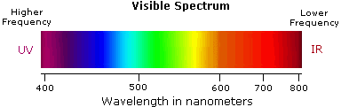
- Violet: 400 - 420 nm
- Indigo: 420 - 440 nm
- Blue: 440 - 490 nm
- Green: 490 -570nm
- Orange: 585 - 620 nm
- Red: 620 - 780 nm
- Yellow: 570 - 585 nm
When white light passes through or is reflected by a colored substance, a characteristic portion of the mixed wavelengths is absorbed. The remaining light will then assume the complementary color to the wavelength(s) absorbed. This relationship is demonstrated by the color wheel shown on the right. Here, complementary colors are diametrically opposite each other. Thus, absorption of 420-430 nm light renders a substance yellow, and absorption of 500-520 nm light makes it red. Green is unique in that it can be created by absoption close to 400 nm as well as absorption near 800 nm.
Early humans valued colored pigments, and used them for decorative purposes. Many of these were inorganic minerals, but several important organic dyes were also known. These included the crimson pigment, kermesic acid, the blue dye, indigo, and the yellow saffron pigment, crocetin. A rare dibromo-indigo derivative, punicin, was used to color the robes of the royal and wealthy. The deep orange hydrocarbon carotene is widely distributed in plants, but is not sufficiently stable to be used as permanent pigment, other than for food coloring. A common feature of all these colored compounds, displayed below, is a system of extensively conjugated pi-electrons.
Ultraviolet–visible spectroscopy or ultraviolet-visible spectrophotometry (UV-Vis or UV/Vis) refers to absorption spectroscopy or reflectance spectroscopy in the ultraviolet-visible spectral region. This means it uses light in the visible and adjacent (near-UV and near-infrared[NIR]) ranges. The absorption or reflectance in the visible range directly affects the perceived color of the chemicals involved. In this region of the electromagnetic spectrum, molecules undergo electronic transitions. This technique is complementary to fluorescence spectroscopy, in that fluorescence deals with transitions from the excited state to the ground state, while absorption measures transitions from the ground state to the excited state.
The basic parts of a spectrophotometer are a light source, a holder for the sample, a diffraction grating in a mono-chromator or a prism to separate the different wavelengths of light, and a detector. The radiation source is often a Tungsten filament (300-2500 nm), a deuterium arc lamp, which is continuous over the ultraviolet region (190-400 nm),Xenon arc lamp, which is continuous from 160-2,000 nm; or more recently, light emitting diodes (LED)^{[1]} for the visible wavelengths. The detector is typically a photomultiplier tube, a photodiode, a photodiode array or a charge-coupled device (CCD). Single photodiode detectors and photomultiplier tubes are used with scanning mono-chromators, which filter the light so that only light of a single wavelength reaches the detector at one time. The scanning monochromator moves the diffraction grating to "step-through" each wavelength so that its intensity may be measured as a function of wavelength. Fixed monochromators are used with CCDs and photodiode arrays. As both of these devices consist of many detectors grouped into one or two dimensional arrays, they are able to collect light of different wavelengths on different pixels or groups of pixels simultaneously.
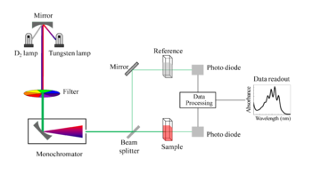
Schematic of UV- visible spectrophotometer.
A spectrophotometer can be either single beam or double beam. In a single beam instrument (such as the Spectronic 20), all of the light passes through the sample cell. must be measured by removing the sample. This was the earliest design and is still in common use in both teaching and industrial labs.
In a double-beam instrument, the light is split into two beams before it reaches the sample. One beam is used as the reference; the other beam passes through the sample. The reference beam intensity is taken as 100% Transmission (or 0 Absorbance), and the measurement displayed is the ratio of the two beam intensities. Some double-beam instruments have two detectors (photodiodes), and the sample and reference beam are measured at the same time. In other instruments, the two beams pass through a beam chopper, which blocks one beam at a time. The detector alternates between measuring the sample beam and the reference beam in synchronism with the chopper. There may also be one or more dark intervals in the chopper cycle. In this case, the measured beam intensities may be corrected by subtracting the intensity measured in the dark interval before the ratio is taken.
Samples for UV/Vis spectrophotometry are most often liquids, although the absorbance of gases and even of solids can also be measured. Samples are typically placed in a transparent cell, known as a cuvette. Cuvettes are typically rectangular in shape, commonly with an internal width of 1 cm. (This width becomes the path length, , in the Beer-Lambert law.) Test tubes can also be used as cuvettes in some instruments. The type of sample container used must allow radiation to pass over the spectral region of interest. The most widely applicable cuvettes are made of high quality fused silica or quartz glass because these are transparent throughout the UV, visible and near infrared regions. Glass and plastic cuvettes are also common, although glass and most plastics absorb in the UV, which limits their usefulness to visible wavelengths.^{[1]}
Specialized instruments have also been made. These include attaching spectrophotometers to telescopes to measure the spectra of astronomical features. UV-visible microspectrophotometers consist of a UV-visible microscope integrated with a UV-visible spectrophotometer.
A complete spectrum of the absorption at all wavelengths of interest can often be produced directly by a more sophisticated spectrophotometer. In simpler instruments the absorption is determined one wavelength at a time and then compiled into a spectrum by the operator. By removing the concentration dependence, the extinction coefficient (ε) can be determined as a function of wavelength.
